UNIT 4 - SOFTWARE PROJECT MANAGEMENT

4P’s of Management Spectrum:-

For properly building a product, there’s a very important concept that we all should know in software project planning while developing a product. There are 4 critical components in software project planning which are known as the 4P’s namely:

- Product
- Process
- People
- Project

These components play a very important role in your project that can help your team meet its goals and objective. Now, Let’s dive into each of them a little in detail to get a better understanding:

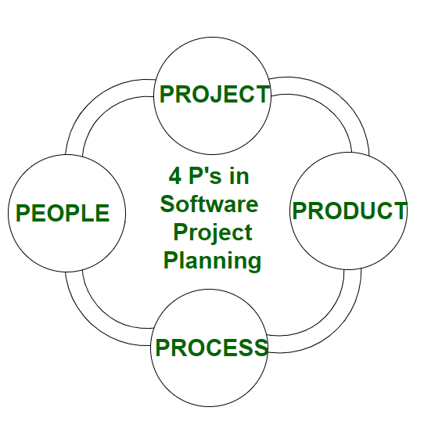

People
The most important component of a product and its successful implementation is human resources. In building a proper product, a well-managed team with clear-cut roles defined for each person/team will lead to the success of the product. We need to have a good team in order to save our time, cost, and effort. Some assigned roles in software project planning are project manager, team leaders, stakeholders, analysts, and other IT professionals. Managing people successfully is a tricky process which a good project manager can do.

Product
As the name inferred, this is the deliverable or the result of the project. The project manager should clearly define the product scope to ensure a successful result, control the team members, as well technical hurdles that he or she may encounter during the building of a product. The product can consist of both tangible or intangible such as shifting the company to a new place or getting a new software in a company.

Process
In every planning, a clearly defined process is the key to the success of any product. It regulates how the team will go about its development in the respective time period. The Process has several steps involved like, documentation phase, implementation phase, deployment phase, and interaction phase.

Project
The last and final P in software project planning is Project. In this phase, the project manager plays a critical role. They are responsible to guide the team members to achieve the project’s target and objectives, helping & assisting them with issues, checking on cost and budget, and making sure that the project stays on track with the given deadlines.

LOC and Function Points:

Lines of Code (LOC):
LOC is possibly the simplest among all metrics available to measure project size. Consequently, this metric is extremely popular. This metric measures the size of a project by counting the number of source instructions in the developed program. While counting the number of source instructions, comment lines, and header lines are ignored.
It determines the LOC count at the end of a project which is very simple. However, accurate estimation of LOC count at the beginning of a project is a very difficult task.
Features :
- Variations such as “source lines of code”, are used to set out a codebase.
- LOC is frequently used in some kinds of arguments.
- They are used in assessing a p4roject’s performance or efficiency.
Advantages :
- Most used metric in cost estimation.
- It’s alternates have many problems as compared to this metric.
- It is very easy in estimating the efforts.

Disadvantages :
- Very difficult to estimate the LOC of the final program from the problem specification.
- It correlates poorly with quality and efficiency of code.
- It doesn’t consider complexity.

Function Points:
FP metric was proposed by Albrecht in 1983. This metric overcomes many of the shortcomings of the LOC metric. Since its inception in the late 1970s, the function point metric has steadily gained popularity. The function point metric has several advantages over the LOC metric. One of the important advantages of the function point metric over the LOC metric is that it can easily be computed from the problem specification itself. Using the LOC metric, on the other hand, the size can accurately be determined only after the product has fully been developed.

The conceptual idea behind the function point metric is that the size of a software product is directly dependent on the number of different high-level functions. This assumption is reasonable since each feature would take additional effort to implement.

Objectives of FPA
The basic and primary purpose of the functional point analysis is to measure and provide the software application functional size to the client, customer, and the stakeholder on their request. Further, it is used to measure the software project development along with its maintenance, consistently throughout the project irrespective of the tools and the technologies.
Following are the points regarding FPs
1. FPs of an application is found out by counting the number and types of functions used in the applications. Various functions used in an application can be put under five types, as shown in Table:
Types of FP Attributes
Measurements Parameters | Examples
1.Number of External Inputs(EI) | Input screen and tables
2. Number of External Output (EO) | Output screens and reports
3. Number of external inquiries (EQ) | Prompts and interrupts.
4. Number of internal files (ILF) | Databases and directories
5. Number of external interfaces (EIF) | Shared databases and shared routines.
All these parameters are then individually assessed for complexity.
The FPA functional units are shown in Fig:
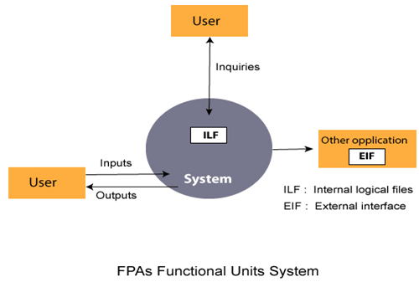
2. FP characterizes the complexity of the software system and hence can be used to depict the project time and the manpower requirement.
3. The effort required to develop the project depends on what the software does.
4. FP is programming language independent.
5. FP method is used for data processing systems, business systems like information systems.
6. The five parameters mentioned above are also known as information domain characteristics.
7. All the parameters mentioned above are assigned some weights that have been experimentally determined and are shown in Table
Weights of 5-FP Attributes
Measurement Parameter | Low | Average | High
1. Number of external inputs (EI) | 7 | 10 | 15
2. Number of external outputs (EO) | 5 | 7 | 10
3. Number of external inquiries (EQ) | 3 | 4 | 6
4. Number of internal files (ILF) | 4 | 5 | 7
5. Number of external interfaces (EIF) | 3 | 4 | 6
The functional complexities are multiplied with the corresponding weights against each function, and the values are added up to determine the UFP (Unadjusted Function Point) of the subsystem.
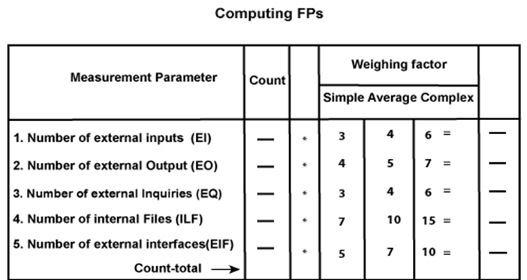
Here that weighing factor will be simple, average, or complex for a measurement parameter type.
The Function Point (FP) is thus calculated with the following formula.
FP = Count-total * [0.65 + 0.01 * ∑(f_{i})]
= Count-total * CAF
where Count-total is obtained from the above Table.
CAF = [0.65 + 0.01 *∑(f_{i})]
and ∑(f_{i}) is the sum of all 14 questionnaires and show the complexity adjustment value/ factor-CAF (where i ranges from 1 to 14). Usually, a student is provided with the value of ∑(f_{i})
Also note that ∑(f_{i}) ranges from 0 to 70, i.e.,
0 <= ∑(f_{i}) <=70
and CAF ranges from 0.65 to 1.35 because
- When ∑(f_{i}) = 0 then CAF = 0.65
- When ∑(f_{i}) = 70 then CAF = 0.65 + (0.01 * 70) = 0.65 + 0.7 = 1.35
Based on the FP measure of software many other metrics can be computed:
- Errors/FP
- $/FP.
- Defects/FP
- Pages of documentation/FP
- Errors/PM.
- Productivity = FP/PM (effort is measured in person-months).
- $/Page of Documentation.
8. LOCs of an application can be estimated from FPs. That is, they are interconvertible. This process is known as backfiring. For example, 1 FP is equal to about 100 lines of COBOL code.
9. FP metrics is used mostly for measuring the size of Management Information System (MIS) software.
10. But the function points obtained above are unadjusted function points (UFPs). These (UFPs) of a subsystem are further adjusted by considering some more General System Characteristics (GSCs). It is a set of 14 GSCs that need to be considered. The procedure for adjusting UFPs is as follows:
- Degree of Influence (DI) for each of these 14 GSCs is assessed on a scale of 0 to 5. (b) If a particular GSC has no influence, then its weight is taken as 0 and if it has a strong influence then its weight is 5.
- The score of all 14 GSCs is totaled to determine Total Degree of Influence (TDI).
- Then Value Adjustment Factor (VAF) is computed from TDI by using the formula: VAF = (TDI * 0.01) + 0.65
Remember that the value of VAF lies within 0.65 to 1.35 because
- When TDI = 0, VAF = 0.65
- When TDI = 70, VAF = 1.35
- VAF is then multiplied with the UFP to get the final FP count: FP = VAF * UFP
Example: Compute the function point, productivity, documentation, cost per function for the following data:
- Number of user inputs = 24
- Number of user outputs = 46
- Number of inquiries = 8
- Number of files = 4
- Number of external interfaces = 2
- Effort = 36.9 p-m
- Technical documents = 265 pages
- User documents = 122 pages
- Cost = $7744/ month
Various processing complexity factors are: 4, 1, 0, 3, 3, 5, 4, 4, 3, 3, 2, 2, 4, 5.
Solution:
Measurement Parameter | Count |  | Weighing factor
1. Number of external inputs (EI) | 24 | * | 4 = 96
2. Number of external outputs (EO) | 46 | * | 4 = 184
3. Number of external inquiries (EQ) | 8 | * | 6 = 48
4. Number of internal files (ILF) | 4 | * | 10 = 40
5. Number of external interfaces (EIF) Count-total → | 2 | * | 5 = 10  378
So sum of all f_{i} (i ← 1 to 14) = 4 + 1 + 0 + 3 + 5 + 4 + 4 + 3 + 3 + 2 + 2 + 4 + 5 = 43
FP = Count-total * [0.65 + 0.01 *∑(f_{i})]
= 378 * [0.65 + 0.01 * 43]
= 378 * [0.65 + 0.43]
= 378 * 1.08 = 408
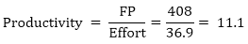
Total pages of documentation = technical document + user document
= 265 + 122 = 387pages
Documentation = Pages of documentation/FP
= 387/408 = 0.94
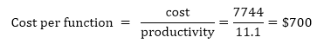

Differentiate between FP and LOC
FP | LOC
1. FP is specification based. | 1. LOC is an analogy based.
2. FP is language independent. | 2. LOC is language dependent.
3. FP is user-oriented. | 3. LOC is design-oriented.
4. It is extendible to LOC. | 4. It is convertible to FP (backfiring)

Software Project Cost Estimation Approaches:
For any new software project, it is necessary to know how much it will cost to develop and how much development time will it take. These estimates are needed before development is initiated, but how is this done? Several estimation procedures have been developed and are having the following attributes in common.
- Project scope must be established in advanced.
- Software metrics are used as a support from which evaluation is made.
- The project is broken into small PCs which are estimated individually.
To achieve true cost & schedule estimate, several option arise.
- Delay estimation.
- Used symbol decomposition techniques to generate project cost and schedule estimates.
- Acquire one or more automated estimation tools.

Uses of Cost Estimation
- During the planning stage, one needs to choose how many engineers are required for the project and to develop a schedule.
- In monitoring the project's progress, one needs to access whether the project is progressing according to the procedure and takes corrective action, if necessary.

Cost Estimation Models
Cost estimation simply means a technique that is used to find out the cost estimates. The cost estimate is the financial spend that is done on the efforts to develop and test software in Software Engineering. Cost estimation models are some mathematical algorithms or parametric equations that are used to estimate the cost of a product or a project.
Various techniques or models are available for cost estimation, also known as Cost Estimation Models as shown below :
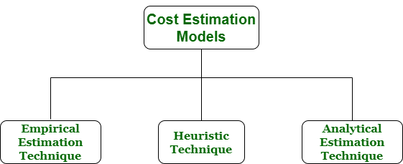
Empirical Estimation Technique –
Empirical estimation is a technique or model in which empirically derived formulas are used for predicting the data that are a required and essential part of the software project planning step. These techniques are usually based on the data that is collected previously from a project and also based on some guesses, prior experience with the development of similar types of projects, and assumptions. It uses the size of the software to estimate the effort.
In this technique, an educated guess of project parameters is made. Hence, these models are based on common sense. However, as there are many activities involved in empirical estimation techniques, this technique is formalized. For example Delphi technique and Expert Judgement technique.
Heuristic Technique –
Heuristic word is derived from a Greek word that means “to discover”. The heuristic technique is a technique or model that is used for solving problems, learning, or discovery in the practical methods which are used for achieving immediate goals. These techniques are flexible and simple for taking quick decisions through shortcuts and good enough calculations, most probably when working with complex data. But the decisions that are made using this technique are necessary to be optimal.
In this technique, the relationship among different project parameters is expressed using mathematical equations. The popular heuristic technique is given by Constructive Cost Model (COCOMO). This technique is also used to increase or speed up the analysis and investment decisions.
Analytical Estimation Technique –
Analytical estimation is a type of technique that is used to measure work. In this technique, firstly the task is divided or broken down into its basic component operations or elements for analyzing. Second, if the standard time is available from some other source, then these sources are applied to each element or component of work.
Third, if there is no such time available, then the work is estimated based on the experience of the work. In this technique, results are derived by making certain basic assumptions about the project. Hence, the analytical estimation technique has some scientific basis. Halstead’s software science is based on an analytical estimation model.
COCOMO Model

COCOMO Model
- Boehm proposed COCOMO (Constructive Cost Estimation Model) in 1981.
- COCOMO is one of the most generally used software estimation models in the world.
- COCOMO predicts the efforts and schedule of a software product based on the size of the software.
The necessary steps in this model are:
- Get an initial estimate of the development effort from evaluation of thousands of delivered lines of source code (KDLOC).
- Determine a set of 15 multiplying factors from various attributes of the project.
- Calculate the effort estimate by multiplying the initial estimate with all the multiplying factors i.e., multiply the values in step1 and step2.
The initial estimate (also called nominal estimate) is determined by an equation of the form used in the static single variable models, using KDLOC as the measure of the size. To determine the initial effort E_{i} in person-months the equation used is of the type is shown below
E_{i}=a*(KDLOC)b
The value of the constant a and b are depends on the project type.
In COCOMO, projects are categorized into three types:
- Organic
- Semidetached
- Embedded
1.Organic: A development project can be treated of the organic type, if the project deals with developing a well-understood application program, the size of the development team is reasonably small, and the team members are experienced in developing similar methods of projects. Examples of this type of projects are simple business systems, simple inventory management systems, and data processing systems.
2. Semidetached: A development project can be treated with semidetached type if the development consists of a mixture of experienced and inexperienced staff. Team members may have finite experience in related systems but may be unfamiliar with some aspects of the order being developed. Example of Semidetached system includes developing a new operating system (OS), a Database Management System (DBMS), and complex inventory management system.
3. Embedded: A development project is treated to be of an embedded type, if the software being developed is strongly coupled to complex hardware, or if the stringent regulations on the operational method exist. For Example: ATM, Air Traffic control.
For three product categories, Bohem provides a different set of expression to predict effort (in a unit of person month)and development time from the size of estimation in KLOC(Kilo Line of code) efforts estimation takes into account the productivity loss due to holidays, weekly off, coffee breaks, etc.
According to Boehm, software cost estimation should be done through three stages:
- Basic Model
- Intermediate Model
- Detailed Model

1. Basic COCOMO Model: The basic COCOMO model provide an accurate size of the project parameters. The following expressions give the basic COCOMO estimation model:
Effort=a₁*(KLOC) a₂ PM
Tdev=b₁*(efforts)b₂ Months
Where
KLOC is the estimated size of the software product indicate in Kilo Lines of Code,
a₁,a₂,b₁,b₂ are constants for each group of software products,
Tdev is the estimated time to develop the software, expressed in months,
Effort is the total effort required to develop the software product, expressed in person months (PMs).
Estimation of development effort
For the three classes of software products, the formulas for estimating the effort based on the code size are shown below:
Organic: Effort = 2.4(KLOC) 1.05 PM
Semi-detached: Effort = 3.0(KLOC) 1.12 PM
Embedded: Effort = 3.6(KLOC) 1.20 PM
Estimation of development time
For the three classes of software products, the formulas for estimating the development time based on the effort are given below:
Organic: Tdev = 2.5(Effort) 0.38 Months
Semi-detached: Tdev = 2.5(Effort) 0.35 Months
Embedded: Tdev = 2.5(Effort) 0.32 Months
Some insight into the basic COCOMO model can be obtained by plotting the estimated characteristics for different software sizes. Fig shows a plot of estimated effort versus product size. From fig, we can observe that the effort is somewhat superliner in the size of the software product. Thus, the effort required to develop a product increases very rapidly with project size.
Example1: Suppose a project was estimated to be 400 KLOC. Calculate the effort and development time for each of the three model i.e., organic, semi-detached & embedded.
Solution: The basic COCOMO equation takes the form:
Effort=a₁*(KLOC) a₂ PM
Tdev=b₁*(efforts)b₂ Months
Estimated Size of project= 400 KLOC
(i)Organic Mode
E = 2.4 * (400)1.05 = 1295.31 PM
D = 2.5 * (1295.31)0.38=38.07 PM
(ii)Semidetached Mode
E = 3.0 * (400)1.12=2462.79 PM
D = 2.5 * (2462.79)0.35=38.45 PM
(iii) Embedded Mode
E = 3.6 * (400)1.20 = 4772.81 PM
D = 2.5 * (4772.8)0.32 = 38 PM
Example2: A project size of 200 KLOC is to be developed. Software development team has average experience on similar type of projects. The project schedule is not very tight. Calculate the Effort, development time, average staff size, and productivity of the project.
Solution: The semidetached mode is the most appropriate mode, keeping in view the size, schedule and experience of development time.
Hence E=3.0(200)1.12=1133.12PM
D=2.5(1133.12)0.35=29.3PM
P = 176 LOC/PM
2. Intermediate Model: The basic Cocomo model considers that the effort is only a function of the number of lines of code and some constants calculated according to the various software systems. The intermediate COCOMO model recognizes these facts and refines the initial estimates obtained through the basic COCOMO model by using a set of 15 cost drivers based on various attributes of software engineering.
Classification of Cost Drivers and their attributes:
(i) Product attributes -
- Required software reliability extent
- Size of the application database
- The complexity of the product
Hardware attributes -
- Run-time performance constraints
- Memory constraints
- The volatility of the virtual machine environment
- Required turnabout time

Personnel attributes -
- Analyst capability
- Software engineering capability
- Applications experience
- Virtual machine experience
- Programming language experience
Project attributes -
- Use of software tools
- Application of software engineering methods
- Required development schedule
The cost drivers are divided into four categories:

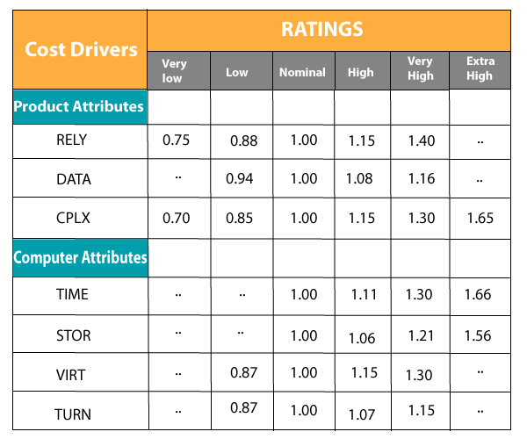

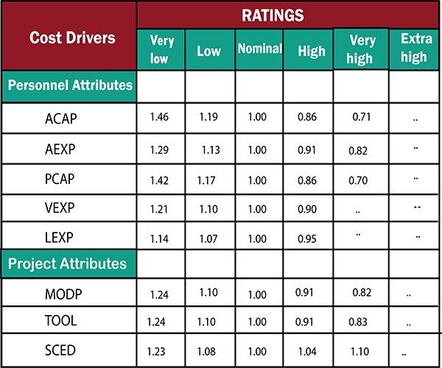
Intermediate COCOMO equation:
E=a_{i} (KLOC) b_{i}*EAF
D=c_{i} (E)d_{i}
Coefficients for intermediate COCOMO
Project | a_{i} | b_{i} | c_{i} | d_{i}
Organic | 2.4 | 1.05 | 2.5 | 0.38
Semidetached | 3.0 | 1.12 | 2.5 | 0.35
Embedded | 3.6 | 1.20 | 2.5 | 0.32
3. Detailed COCOMO Model: Detailed COCOMO incorporates all qualities of the standard version with an assessment of the cost driver?s effect on each method of the software engineering process. The detailed model uses various effort multipliers for each cost driver property. In detailed cocomo, the whole software is differentiated into multiple modules, and then we apply COCOMO in various modules to estimate effort and then sum the effort.
The Six phases of detailed COCOMO are:
- Planning and requirements
- System structure
- Complete structure
- Module code and test
- Integration and test
- Cost Constructive model
The effort is determined as a function of program estimate, and a set of cost drivers are given according to every phase of the software lifecycle.
COCOMO-II

COCOMO-II is the revised version of the original Cocomo (Constructive Cost Model) and is developed at University of Southern California. It is the model that allows one to estimate the cost, effort and schedule when planning a new software development activity.

It consists of three sub-models:
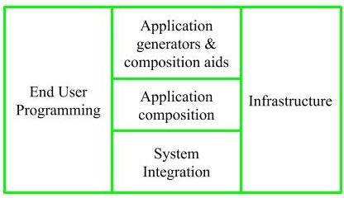
1. End User Programming:
Application generators are used in this sub-model. End user write the code by using these application generators.
Example – Spreadsheets, report generator, etc.
2. Intermediate Sector:
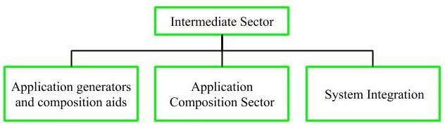
(a). Application Generators and Composition Aids –
This category will create largely prepackaged capabilities for user programming. Their product will have many reusable components. Typical firms operating in this sector are Microsoft, Lotus,
Oracle, IBM, Borland, Novell.
(b). Application Composition Sector –
This category is too diversified and to be handled by prepackaged solutions. It includes GUI, Databases, domain specific components such as financial, medical or industrial process control packages.
(c). System Integration –
This category deals with large scale and highly embedded systems.
3. Infrastructure Sector:
This category provides infrastructure for the software development like Operating System, Database Management System, User Interface Management System, Networking System, etc.
Stages of COCOMO II:
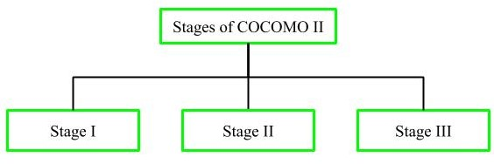
Stage-I:
It supports estimation of prototyping. For this it uses Application Composition Estimation Model. This model is used for the prototyping stage of application generator and system integration.
Stage-II:
It supports estimation in the early design stage of the project, when we less know about it. For this it uses Early Design Estimation Model. This model is used in early design stage of application generators, infrastructure, system integration.
Stage-III:
It supports estimation in the post architecture stage of a project. For this it uses Post Architecture Estimation Model. This model is used after the completion of the detailed architecture of application generator, infrastructure, system integration.

Difference between COCOMO 1 and COCOMO 2:

COCOMO I | COCOMO II
COCOMO I is useful in the waterfall models of the software development cycle. | COCOMO II is useful in non-sequential, rapid development and reuse models of software.
It provides estimates of effort and schedule. | It provides estimates that represent one standard deviation around the most likely estimate.
This model is based upon the linear reuse formula. | This model is based upon the non linear reuse formula
This model is also based upon the assumption of reasonably stable requirements. | This model is also based upon reuse model which looks at effort needed to understand and estimate.
Effort equation’s exponent is determined by 3 development modes. | Effort equation’s exponent is determined by 5 scale factors.
Development begins with the requirements assigned to the software. | It follows a spiral type of development.
Number of submodels in COCOMO I is 3 and 15 cost drivers are assigned | In COCOMO II, Number of submodel are 4 and 17 cost drivers are assigned
Size of software stated in terms of Lines of code | Size of software stated in terms of Object points, function points and lines of code

Application Composition Estimation Model allows one to estimate the cost, effort at the stage 1 of the COCOMO II Model.
In this model size is first estimated using Object Points. Object Points are easy to identify and count. Object Points defines screen, reports, third generation (3GL) modules as objects.
Object Point estimation is a new size estimation technique but it is well suited in Application Composition Sector.
Estimation of Efforts:
Following steps are taken to estimate effort to develop a project
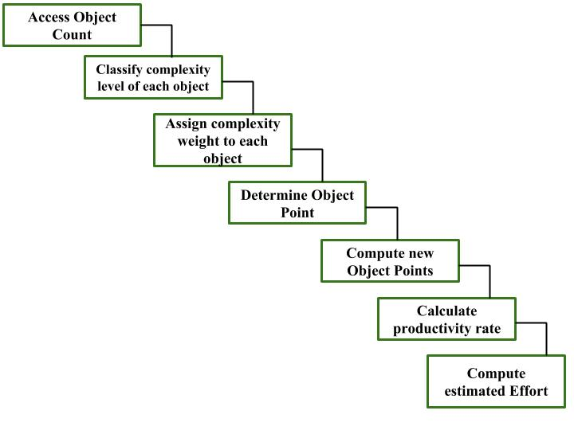
Step-1: Access Object counts
Estimate the number of screens, reports and 3GL components that will comprise this application.
Step-2: Classify complexity levels of each object
We have to classify each object instance into simple, medium and difficult complexity level depending on values of its characteristics.
Complexity levels are assigned according to the given table
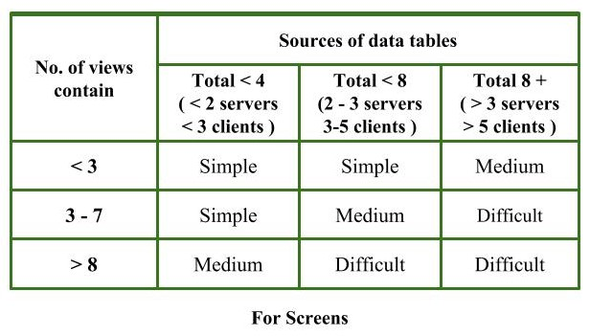
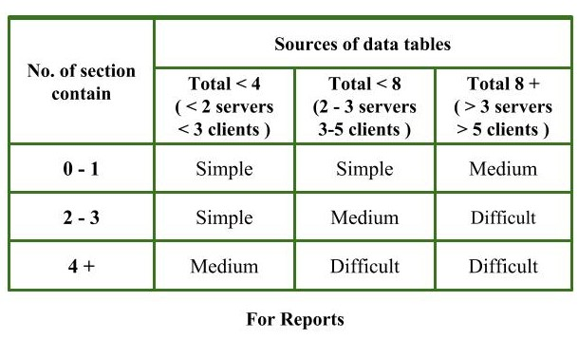
Step-3: Assign complexity weights to each object
The weights are used for three object types i.e, screens, reports and 3GL components.
Complexity weight are assigned according to object’s complexity level using following table
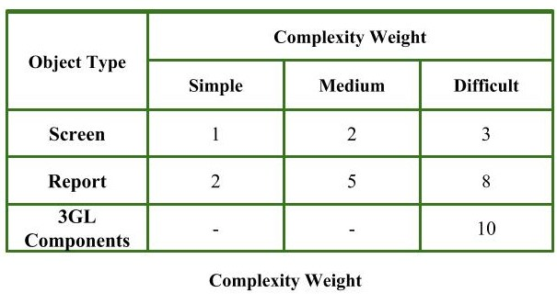
Step-4: Determine Object Points
Add all the weighted object instances to get one number and this is known as object point count.
Object Point
= Sigma (number of object instances)
* (Complexity weight of each object instance)
Step-5: Compute New Object Points (NOP)
We have to estimate the %reuse to be achieved in a project.
Depending on %reuse
NOP = [(object points) * (100 - %reuse)]/100
NOP are the object point that will need to be developed and differ from the object point count because there may be reuse of some object instance in project.
Step-6: Calculate Productivity rate (PROD)
Productivity rate is calculated on the basis of information given about developer’s experience and capability.
For calculating it, we use following table
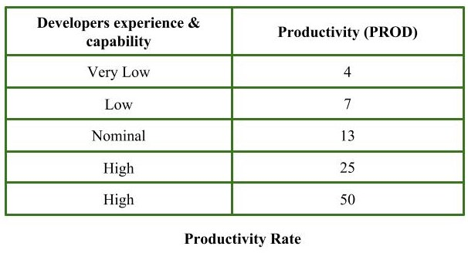
Step-7: Compute the estimated Effort
Effort to develop a project can be calculated as
Effort = NOP/PROD
Effort is measured in person-month.
Example:
Consider a database application project with
- The application has four screens with four views each and seven data tables for three servers and four clients.
- Application may generate two reports of six section each from seven data tables for two servers and three clients.
10% reuse of object points.
Developer’s experience and capability in similar environment is low. Calculate the object point count, New object point and effort to develop such project.
Step-1:
Number of screens = 4
Number of records = 2
Step-2:
For screens,
Number of views = 4
Number of data tables = 7
Number of servers = 3
Number of clients = 4
by using above given information and table (For Screens),
Complexity level for each screen = medium
For reports,
Number of sections = 6
Number of data tables = 7
Number of servers = 2
Number of clients = 3
by using above given information and table (For Reports),
Complexity level for each report = difficult
Step-3:
By using complexity weight table we can assign complexity weight to each object instance depending upon their complexity level.
Complexity weight for each screen = 2
Complexity weight for each report = 8
Step-4:
Object point count
= sigma (Number of object instances) * (its Complexity weight)
= 4 * 2 + 2 * 8 = 24
Step-5:
%reuse of object points = 10% (given)
NOP = [object points * (100 - %reuse)]/100
= [24 * (100 -10)]/100 = 21.6
Step-6:
Developer’s experience and capability is low (given)
Using information given about developer and productivity rate table
Productivity rate (PROD) of given project = 7
Step-7:
Effort
= NOP/PROD
= 21.6/7
= 3.086 person-month
Therefore, effort to develop the given project = 3.086 person-month.

RISK MANAGEMENT:-

Risk Management is the system of identifying addressing and eliminating these problems before they can damage the project.
We need to differentiate risks, as potential issues, from the current problems of the project.
Different methods are required to address these two kinds of issues.
For example, staff storage, because we have not been able to select people with the right technical skills is a current problem, but the threat of our technical persons being hired away by the competition is a risk.
A software project can be concerned with a large variety of risks. In order to be adept to systematically identify the significant risks which might affect a software project, it is essential to classify risks into different classes. The project manager can then check which risks from each class are relevant to the project.
There are three main classifications of risks which can affect a software project:
- Project risks
- Technical risks
- Business risks
1. Project risks: Project risks concern differ forms of budgetary, schedule, personnel, resource, and customer-related problems. A vital project risk is schedule slippage. Since the software is intangible, it is very tough to monitor and control a software project. It is very tough to control something which cannot be identified. For any manufacturing program, such as the manufacturing of cars, the plan executive can recognize the product taking shape.
2. Technical risks: Technical risks concern potential method, implementation, interfacing, testing, and maintenance issue. It also consists of an ambiguous specification, incomplete specification, changing specification, technical uncertainty, and technical obsolescence. Most technical risks appear due to the development team's insufficient knowledge about the project.
3. Business risks: This type of risks contain risks of building an excellent product that no one need, losing budgetary or personnel commitments, etc.
Other risk categories
- 1. Known risks: Those risks that can be uncovered after careful assessment of the project program, the business and technical environment in which the plan is being developed, and more reliable data sources (e.g., unrealistic delivery date)
- 2. Predictable risks: Those risks that are hypothesized from previous project experience (e.g., past turnover)
- 3. Unpredictable risks: Those risks that can and do occur, but are extremely tough to identify in advance.

Principle of Risk Management
- Open Communication: This is to allow the free flow of communications between the client and the team members so that they have certainty about the risks.

- Global Perspective: In this, we review the bigger system description, design, and implementation. We look at the chance and the impact the risk is going to have.
- Integrated management: In this method risk management is made an integral part of project management,
- Take a forward-looking view: Consider the threat which may appear in the future and create future plans for directing the next events.
- Continuous process: In this phase, the risks are tracked continuously throughout the risk management paradigm.
What is Reactive Risk Management?
Reactive risk management is often compared to a firefighting scenario. The reactive risk management kicks into action once an accident happens, or problems are identified after the audit. The accident is investigated, and measures are taken to avoid similar events happening in the future. Further, measures will be taken to reduce the negative impact the incident could cause on business profitability and sustainability.
Reactive risk management catalogues all previous accidents and documents them to find the errors which lead to the accident. Preventive measures are recommended and implemented via the reactive risk management method. This is the earlier model of risk management. Reactive risk management can cause serious delays in a workplace due to the unpreparedness for new accidents. The unpreparedness makes the resolving process complex as the cause of accident needs investigation and solution involve high cost, plus extensive modification.

What is Proactive Risk Management?
Contrary to reactive risk management, proactive risk management seeks to identify all relevant risks earlier, before an incident occurs. The present organization has to deal with an era of rapid environmental change that is caused by technological advancements, deregulation, fierce competition, and increasing public concern. So, a risk management which relies on past incidents is not a good choice for any organization. Therefore, new thinking in risk management was necessary, which paved the way for proactive risk management.
Proactive risk management can be defined as “Adaptive, closed loop feedback control strategy based on measurement, observation of the present safety level and planned explicit target safety level with a creative intellectuality”. The definition relates to the flexibility and creative intellectual power of humans who have a high sense of safety concern. Though, humans are the source of error, they can also be a very important safety source as per proactive risk management. Further, the closed loop strategy refers to setting up of boundaries to operate within. These boundaries are considered to have safe performance level.
Accidental analysis is part of the proactive risk management, with which accident scenarios are built and the key employees and stakeholders who may create the error for an accident, are identified. So, past accidents are important in proactive risk management as well.

What is the between Proactive and Reactive Risk Management?
Definition of Proactive and Reactive Risk Management
Reactive: “A response based risk management approach, which is dependent on accident evaluation and audit based findings.”
Proactive: “Adaptive, closed loop feedback control strategy based on measurement, observation of the present safety level and planned explicit target safety level with a creative intellectuality.”
Purpose of Proactive and Reactive Risk Management
Reactive risk management: Reactive risk management attempts to reduce the tendency of the same or similar accidents which happened in past being repeated in future.
Proactive risk management: Proactive risk management attempts to reduce the tendency of any accident happening in future by identifying the boundaries of activities, where a breach of the boundary can lead to an accident.
Features of Proactive and Reactive Risk Management
Timeframe
Reactive risk management: Reactive risk management solely depends on past accidental analysis and response.
Proactive risk management: Proactive risk management combines a mixed method of past, present and future prediction before finding solutions to avoid risks.
Flexibility
Reactive risk management: Reactive risk management does not accommodate prediction, creativity, and problem-solving ability of humans in its approach which makes it less flexible to changes and challenges.
Proactive risk management: Proactive risk management includes creative thinking, prediction. Further, it principally depends on the accident source to reduce the accident which is a human attribute. So, this lets it be very adaptive to changing environment.

Risk management consists of three main activities, as shown in fig:
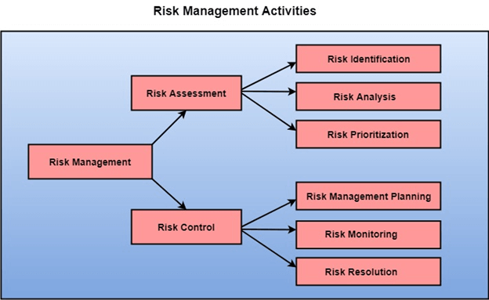

Risk Assessment
The objective of risk assessment is to division the risks in the condition of their loss, causing potential. For risk assessment, first, every risk should be rated in two methods:
- The possibility of a risk coming true (denoted as r).
- The consequence of the issues relates to that risk (denoted as s).
Based on these two methods, the priority of each risk can be estimated:
p = r * s
Where p is the priority with which the risk must be controlled, r is the probability of the risk becoming true, and s is the severity of loss caused due to the risk becoming true. If all identified risks are set up, then the most likely and damaging risks can be controlled first, and more comprehensive risk abatement methods can be designed for these risks.
1. Risk Identification: The project organizer needs to anticipate the risk in the project as early as possible so that the impact of risk can be reduced by making effective risk management planning.
A project can be of use by a large variety of risk. To identify the significant risk, this might affect a project. It is necessary to categories into the different risk of classes.
There are different types of risks which can affect a software project:
- Technology risks: Risks that assume from the software or hardware technologies that are used to develop the system.
- People risks: Risks that are connected with the person in the development team.
- Organizational risks: Risks that assume from the organizational environment where the software is being developed.
- Tools risks: Risks that assume from the software tools and other support software used to create the system.
- Requirement risks: Risks that assume from the changes to the customer requirement and the process of managing the requirements change.
- Estimation risks: Risks that assume from the management estimates of the resources required to build the system
2. Risk Analysis: During the risk analysis process, you have to consider every identified risk and make a perception of the probability and seriousness of that risk.
There is no simple way to do this. You have to rely on your perception and experience of previous projects and the problems that arise in them.
It is not possible to make an exact, the numerical estimate of the probability and seriousness of each risk. Instead, you should authorize the risk to one of several bands:
- The probability of the risk might be determined as very low (0-10%), low (10-25%), moderate (25-50%), high (50-75%) or very high (+75%).
- The effect of the risk might be determined as catastrophic (threaten the survival of the plan), serious (would cause significant delays), tolerable (delays are within allowed contingency), or insignificant.

Risk Control
It is the process of managing risks to achieve desired outcomes. After all, the identified risks of a plan are determined; the project must be made to include the most harmful and the most likely risks. Different risks need different containment methods. In fact, most risks need ingenuity on the part of the project manager in tackling the risk.

There are three main methods to plan for risk management:
- Avoid the risk: This may take several ways such as discussing with the client to change the requirements to decrease the scope of the work, giving incentives to the engineers to avoid the risk of human resources turnover, etc.
- Transfer the risk: This method involves getting the risky element developed by a third party, buying insurance cover, etc.
- Risk reduction: This means planning method to include the loss due to risk. For instance, if there is a risk that some key personnel might leave, new recruitment can be planned.
Risk Mitigation, Monitoring, and Management (RMMM) plan
A risk management technique is usually seen in the software Project plan. This can be divided into Risk Mitigation, Monitoring, and Management Plan (RMMM). In this plan, all works are done as part of risk analysis. As part of the overall project plan project manager generally uses this RMMM plan.
In some software teams, risk is documented with the help of a Risk Information Sheet (RIS). This RIS is controlled by using a database system for easier management of information i.e creation, priority ordering, searching, and other analysis. After documentation of RMMM and start of a project, risk mitigation and monitoring steps will start.
Risk Mitigation :
It is an activity used to avoid problems (Risk Avoidance).
Steps for mitigating the risks as follows.
Finding out the risk.
Removing causes that are the reason for risk creation.
Controlling the corresponding documents from time to time.
Conducting timely reviews to speed up the work.
Risk Monitoring :
It is an activity used for project tracking.
It has the following primary objectives as follows.
To check if predicted risks occur or not.
To ensure proper application of risk aversion steps defined for risk.
To collect data for future risk analysis.
To allocate what problems are caused by which risks throughout the project.
Risk Management and planning :
It assumes that the mitigation activity failed and the risk is a reality. This task is done by Project manager when risk becomes reality and causes severe problems. If the project manager effectively uses project mitigation to remove risks successfully then it is easier to manage the risks. This shows that the response that will be taken for each risk by a manager. The main objective of the risk management plan is the risk register. This risk register describes and focuses on the predicted threats to a software project.
Example:
Let us understand RMMM with the help of an example of high staff turnover.
Risk Mitigation:
To mitigate this risk, project management must develop a strategy for reducing turnover. The possible steps to be taken are:
Meet the current staff to determine causes for turnover (e.g., poor working conditions, low pay, competitive job market).
Mitigate those causes that are under our control before the project starts.
Once the project commences, assume turnover will occur and develop techniques to ensure continuity when people leave.
Organize project teams so that information about each development activity is widely dispersed.
Define documentation standards and establish mechanisms to ensure that documents are developed in a timely manner.
Assign a backup staff member for every critical technologist.
Risk Monitoring:
As the project proceeds, risk monitoring activities commence. The project manager monitors factors that may provide an indication of whether the risk is becoming more or less likely. In the case of high staff turnover, the following factors can be monitored:
General attitude of team members based on project pressures.
Interpersonal relationships among team members.
Potential problems with compensation and benefits.
The availability of jobs within the company and outside it.
Risk Management:
Risk management and contingency planning assumes that mitigation efforts have failed and that the risk has become a reality. Continuing the example, the project is well underway, and a number of people announce that they will be leaving. If the mitigation strategy has been followed, backup is available, information is documented, and knowledge has been dispersed across the team. In addition, the project manager may temporarily refocus resources (and readjust the project schedule) to those functions that are fully staffed, enabling newcomers who must be added to the team to “get up to the speed“.
Drawbacks of RMMM:
It incurs additional project costs.
It takes additional time.
For larger projects, implementing an RMMM may itself turn out to be another tedious project.
RMMM does not guarantee a risk-free project, infact, risks may also come up after the project is delivered.

